CONTACT US PAGE

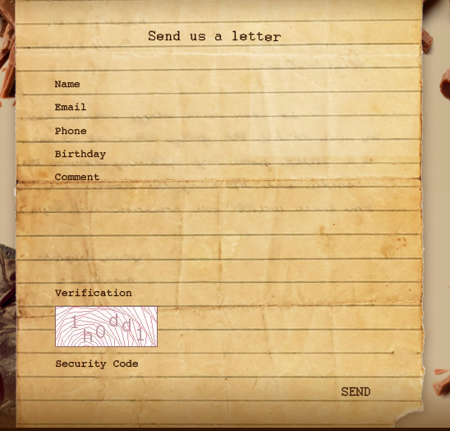

Our Contacts:

Email: chocolatepatisserie@gmail.com

Phone: (+62)21- 5703866

Name: [bisa diisi]

Email: [bisa diisi]

Message: [bisa diisi]

Verification

(captcha)

Code: [bisa diisi]

Submit

Di pinggir kanan

Pas pencet submit, messagenya ke send ke email: aleydis1605@yahoo.com